Chapter 11, Problem 4.

Using Fig. 11.36, design a problem to help other students to better understand instantaneous and average poser.
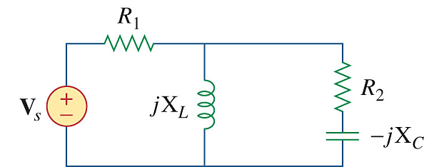

Figure 11.36
For Prob. 11.4.

